Develop a Java program to create a class Bank that
maintains two kinds of account for its customers, one called
savings account and the other current account. The savings
account provides compound interest and withdrawal
facilities but no cheque book facility. The current account
provides cheque book facility but no interest. Current
account holders should also maintain a minimum balance
and if the balance falls below this level, a service charge is
imposed.
Create a class Account that stores customer name, account
number and type of account. From this derive the classes
Cur-acct and Sav-acct to make them more specific to their
requirements. Include the necessary methods in order to
achieve the following tasks:
a) Accept deposit from customer and update the
balance.
b) Display the balance.
c) Compute and deposit interest
d) Permit withdrawal and update the balance
Check for the minimum balance, impose penalty if
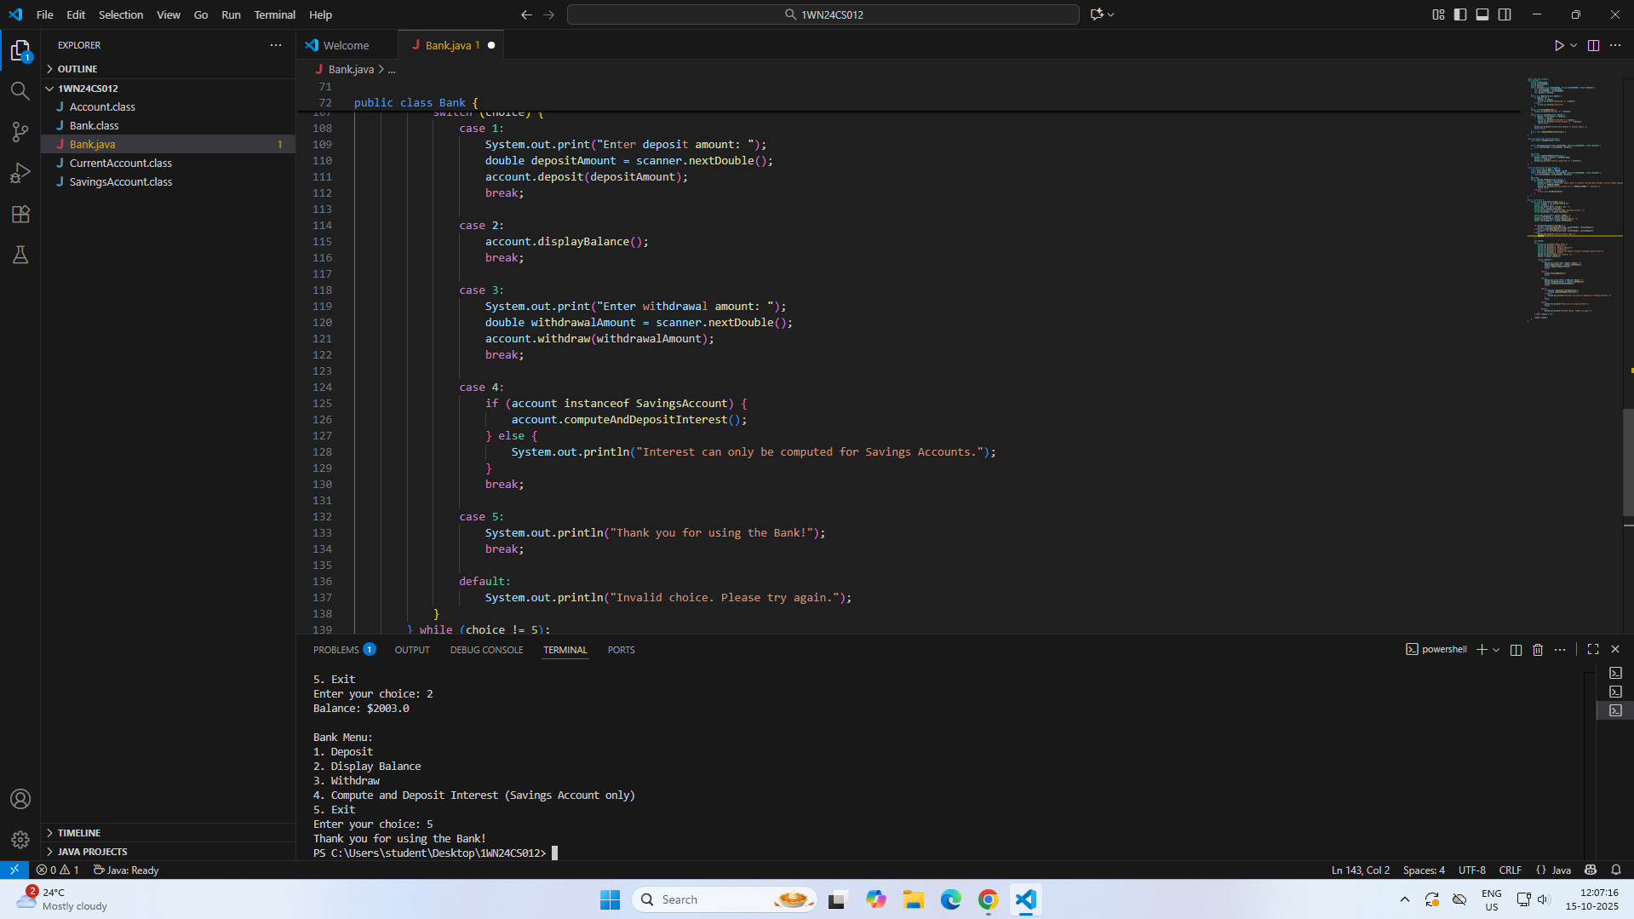
necessary and update the balance.

